**MODULE 3 – Introduction to Business Of EV**

3.1 Electric Vehicle Mobility Business

Practice Problems

### Question 1 Match the following terms to the question that addresses the topic of the term. Each question has one term that is associated. Drag the term to the question.

**Why should we still accept air pollution, climate change and noise produced by our automotive mobility? If we use electric vehicles, these would not be issues.**

Emission

**Why should we risk the depletion of fossil energy resources by our automotive mobility, while we can drive far more efficiently on renewable electricity?**

Energy

**Why would we still want to get stuck in traffic jams, while using automated or autonomous cars, trucks and buses can avoid or by-pass them?**

Congestion

**Why should we still want to risk accidents or road fatalities due to unsafe driving and lack of control by human drivers while automated or autonomous vehicles would be much safer?**

Accident

**Why should we still accept that cars on average utilize 25% of the passenger space while connecting them with an electronic travel data exchange via Internet of Things could use them to full capacity?**

Occupancy

**Why would we still want to spend a lot of money on vehicles that are more parked than moving, while connecting and sharing them, using big data and Internet of Things vehicles can cover their own cost?**

Cost

Submit

### Question 2 A truck with single driver is transporting goods from Vienna to Eindhoven. The total distance to be travelled is 1050 Kilometers. In Europe there is driving time and resting period regulation. This demands that a truck chauffeur, may drive a maximum distance of 360km, after that he or she must rest for three quarters of an hour. Assume that the average speed that chauffeur drives is 80 Km/hr.

How long will it take for the truck to reach Berlin?

1. 14.6 hours
2. 14.0 hours
3. 13.5 hours

Ans. A

### Question 3a The following figure shows a Gartner Hype cycle.

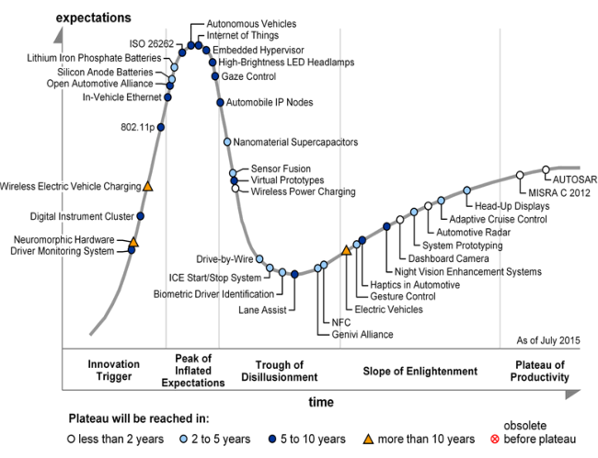

What is false about the Gartner Hype Cycle 2015?

1. The phase 'Innovation Trigger' might signal a breakthrough in the technology development, an initial product launch or interest from the press. This technology is on the rise which sees early adopters investigate their potential benefits.
2. The phase 'Trough of Disillusionment' represents technologies, which tend to meet media/press and public expectations quick enough.
3. The phase 'Slope of Enlightenment' shows companies, which are still working on the technology to understand how it can be improved.
4. The 'Plateau of Productivity' indicates the technologies that had become stable and its benefits have become widely accepted and demonstrated.

Ans. B

### Question 3b In the Gartner Hype cycle, we see three positive disruptive technologies coming together in one decade. What are they?

1. Internet of things, Autonomous vehicles, Electric vehicles.
2. Car sharing, Autonomous vehicles, Renewable energy.
3. ICT, Connectivity, Electric vehicles.

Ans. A